President  Salvo Arena  LL.M. ’00  Vice Presidents  Alexander Chacón  J.D. ’89  Mikko Heinonen  LL.M. ’02  Sascha Hödl  LL.M. ’00  Nathalie Younan  LL.M. ’99  Anne-Caroline Urbain  LL.M. ’06  René A. Pfromm  LL.M. ’08  Philipp Fischer  LL.M. ’09  Elsbeth Kroeze  LL.M. ’04  Michał Bobrzyński  LL.M. ’09  Secretary  Alvyda Usinskaite  LL.M. ’13  Treasurer  Aija Lejniece  LL.M. ’11  Assistant Secretaries  Marco Cesare Laurita  LL.M. ’14  Daniela Ratajova  LL.M. ’12  Federico Raffaele  LL.M. ’12  Governors  Ignacio Arroyo  LL.M. ’75  Roger Benrubi  LL.M. ’50  Guido Brosio  LL.M. ’69  Ronald Dahlman  LL.M. ’74  Felix Dasser  LL.M. ’90  Anne-Marijke  Morgan de Rivery  LL.M. ’80  Alberto Piergrossi  LL.M. ’67  Jacques Sales  LL.M. ’67  William Stevens  LL.M. ’63  Jacques Turco  LL.M. ’67 | To: The Members of the Harvard Law School Association of Europe and other HLS Graduates, connected to, or with an interest in, Europe  Belgrade, April 14, 2017  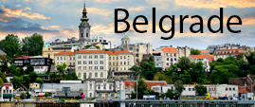  Re: Annual Reunion in Belgrade – May 25 to May 28, 2017  Second Letter  Dear Fellow Alumnae and Alumni:  It is our great pleasure and honor to invite all of you to the 2017 reunion of our Association in Belgrade. Coinciding with the Bicentennial Celebration of Harvard Law School, our reunion promises to be yet another unforgettable experience for all alumnae and alumni!  One of Europe’s best kept tourism secrets, Belgrade is at the crossroads where the Orient meets the West, and while it is not what some would describe as a classically “pretty” capital, it promises a charm drawn from in its grandiose coffee houses, historical buildings, museums and gourmet restaurants.  In Belgrade, we will walk the steps of the ancient Kalemegdan fortress and explore incredibly rich mixture of cultures, influenced by the Ottomans, Romans, Byzantines, Austrians and the Slavs to name a few. Visit will also include a gala reception with the Royal family at the White Palaces while the Academic Session will be hosted at the House of the National Assembly. The program of the reunion is set out in Enclosure 1.  Please register as soon as possible, to secure your registration and participation at this reunion. Information on the registration process is available in Enclosure 2.  Please also make sure that you can benefit from the block reservations we have made at our main partner hotel, Hyatt Regency Belgrade (Reservation form attached) or one of the smaller hotels we’re cooperating with, including 88 Rooms, Radisson Blu Old Mill, Savoy, Opera and Belgrade Inn. Please refer to Enclosure 3 for additional information on hotels. The block reservations are made for a limited number of rooms, which will be allocated on a first come, first served basis.  If you have any questions, please do not hesitate to contact me or any of the Officers. You will find all contact details on our website: www.europe.hlsa.org. Also, please do not hesitate to pass this Second Letter on to your classmates who might not have received it, but could be interested in joining.  Looking forward to seeing you all!  Yours faithfully,  Salvo Arena, LL.M ‘00  Enclosures  Enclosure 1: Program  Enclosure 2: Information on the registration process  Enclosure 3: Information on hotels  Enclosure 4: Map of Belgrade  Enclosure 5: Registration form

Enclosure 1: Program

Thursday, May 25, 2017 | Welcome
18:00 – 22:00 | Welcome drinks and dinner will be served at Shake and Shake “splav” on the river with a prime view of Kalemegdan Fortress. A combination of a DJ and an open bar should prepare the guests to explore the vibrant riverfront nightclubs that offers something for everyone.  For those preferring to spend the dinner in a more private setting, we highly recommend the following restaurants: Question Mark, Homa, Madera, Three Hats, Comunale, Writers’ Club.
Friday, May 26, 2017 | Discover Belgrade
09:00 – 10:30 | Kalemegdan is Belgrade’s birthplace. Tour of the grounds will include a visit to the Roman well, 18th-century Austrian clock tower, Ottoman mausoleum, 19th-century Slavic half-timbered mansion and a military museum surrounded by old tanks and artillery.  (Free bus transportation to the first location will be provided from Hyatt Hotel, leaving at 8:45)
11:00 – 12:00 | A bus tour for sightseeing will start from Kalemegdan where we will board and set on a tour visiting some of the most important landmarks that Belgrade has to offer. In addition, the tour will thoroughly cover various parts of the city’s history together with an expert tour guide’s narrative.
12:00 – 14:00 | Ada Ciganlija is a river island that has artificially been turned into a peninsula most notable for its beaches and recreational facilities which earned it a nickname “Belgrade’s Sea”. Lunch will include a selection of Balkan specialties, including slowly pot-roasted meat and seafood specialties and an open bar with a wide selection of drinks. | 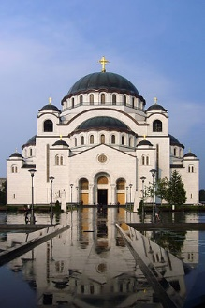
14:30 – 15:15 | Standing at 82 meters, including the cross on the top of the dome, Saint Sava Temple is the largest Orthodox temple in the Balkans, built in the Serbo-Byzantine style. The tour will include a visit to the temple’s crypt, and a walk on the surrounding grounds.
19:00 – 23:00 | We will return to Kalemegdan to visit one of the most iconic restaurants, Kalemegdan Terrace, planted in the side of the fortress overlooking Danube and the Belgrade Zoo, where we will get to experience a traditional Serbian welcome. Following the dinner, entertainment will be provided by a live band that should, together with an open bar, get everyone ready for the prime night of clubbing in the city.  (Free bus transportation will be provided from Hyatt Hotel, leaving at 18:45)
Saturday, May 27, 2017 | Main Program
09:30 – 11:30 | Cruise in a privately chartered boat on the Sava and Danube rivers to explore the city from a different perspective (drinks and snacks served).  (Free bus transportation to the first location will be provided from Hyatt Hotel, leaving at 9:15)
12:00 – 17:30 | The program begins with a tour of the House of the National Assembly (12:00-13:00) that will act as a guide through history, from the Kingdom of Serbia, through the Socialist Federal Republic of Yugoslavia all the way to present day. The session will also include a light brunch and a selection of drinks. | 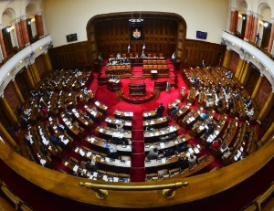
20:00 – 01:00 | The Royal Palaces complex with its magnificent views towards the ridge of Dedinje Hill, Koshutnjak Forest, Topchider and Avala Mountain represents the perfect backdrop for the European celebration of 200 years of Harvard Law School. Following a reception from the Royal family and a group photoshoot, the Association will host the awards ceremony. This year’s keynote address will be delivered by the Serbian Prime Minister, Mr. Aleksandar Vučić.  (Free bus transportation will be provided from Hyatt Hotel, leaving at 19:30) | 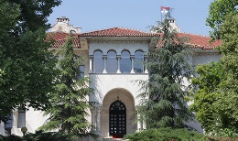
Sunday, May 28, 2017 | Farewell
10:30 – 13:30 | Farewell brunch will be held at the Top of the Hub restaurant with a 360 degree panorama of the city. With the city as the backdrop, the restaurant will serve as a perfect setting to share closing remarks, exchange impressions and bid farewell.  (Hyatt will provide shuttles for the guests to the Nikola Tesla Airport) | 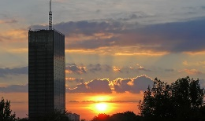

Enclosure 2: Information on the registration process

Option 1
Please register for the reunion by sending the registration form attached as Enclosure 5 to www.europe.hlsa.org and ognjen.popovic@geciclaw.com.

Option 2
We have set up an e-ticket platform where you can pay your registration fees using your credit or debit card. If you wish to use this payment platform and pay online, please use the link to Eventbrite that you will find in our web-site: info@europe.hlsa.org.

Please note that the payment done through the online payment by Eventbrite will bear an additional registration-fee.
Cancellation Policy
We understand that sometimes urgent reasons require cancellations. In such a case, we will strive to refund as much as possible, but please note that we do incur costs also in case of cancellation, especially very late ones as we have to commit ourselves to the various venues, service providers, etc. in advance. Generally, in case of cancellations you may expect a refund of any amount for which we have not, directly or indirectly, made binding commitments with our venues and service providers in Belgrade.

Enclosure 3: Information on hotels

(Official Partner) | King/Twin Room – Single Use 65 EUR  King/Twin Room – Double Use 80 EUR  Deluxe Room– Single Use 95 EUR  Deluxe Room– Double Use 110 EUR  Club King/Twin Room– Single Use 145 EUR  Club King/Twin Room– Double Use 160 EUR  (Breakfast & Wifi included) | Milentija Popovica 5  11000 Belgrade  Link
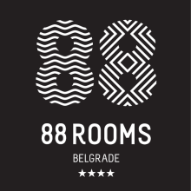 | Single Room: 80 EUR  Double Room: 90 EUR  (Breakfast included) | Takovska 49  11000 Belgrade  Link
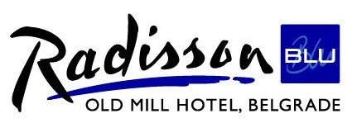 | Single Room: 80 EUR  Double Room: 80 EUR  (Breakfast included) | Bulevar Vojvode Misica 15  11000 Belgrade  Link

The above rates are per night excluding VAT (10%) and tourist tax (1.5 EUR p.p.). All rooms are non-smoking.
Room reservation
In order to book a room, please send an email to Mr. Ognjen Popović, ognjen.popovic@geciclaw.com, with the following information:
- Full name/-s
- Name of hotel (Admiral / Wakeup)
- Room type
- Arrival date
- Departure date
- Nationality
- E-mail address
Questions
If you have any questions regarding the hotel or your reservation, please contact Mr. Ognjen Popović by email ognjen.popovic@geciclaw.com or by phone +381 63 242 048.
Additional Information
We acknowledge that hotels are not everyone’s cup of tea, so we’d like to point out that Airbnb prices in Belgrade are exceptionally affordable, averaging $20-25 for a posh flat for two in the city center.

Enclosure 4: Map of Belgrade

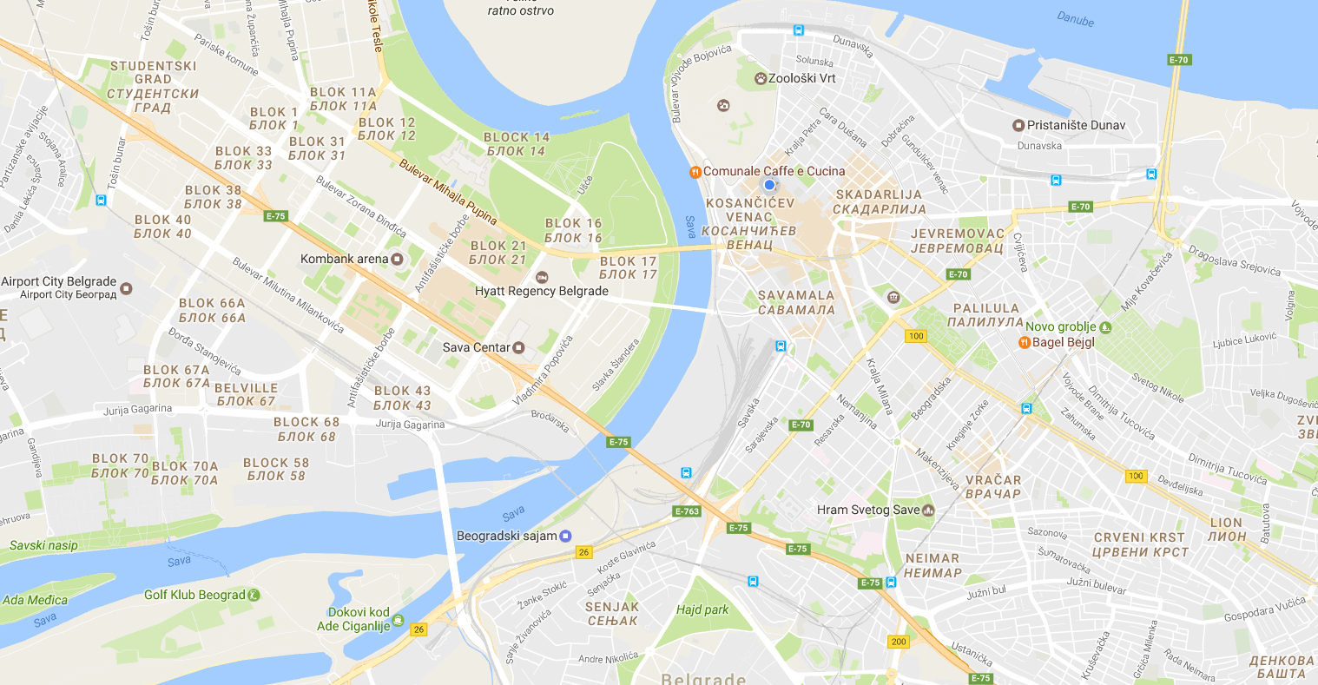
A
A map with most important locations is available at the following link.

Enclosure 5: Registration form

REGISTRATION FORM
(to be returned to info@europe.hlsa.org)
Please fill out this form separately for yourself and for each accompanying person and send it to info@hlsae.eu. Reduced prices are only available for members of the Class of '10 and younger.
Alumni Name and Last Name: | ______________________________________________
Address: | ______________________________________________
Email address: | ______________________________________________
Telephone: | ______________________________________________
Year of Graduation: | ______________________________________________
Guest Name and Last Name (if applicable): | ______________________________________________
Please specify the events you and your guest (if applicable) will be attending:
Thursday, May 25, 2017  Welcome to Belgrade – Drinks & Dinner |  | Alumni <7 year: EUR 25  Alumni >7 year: EUR 30 | Guest: EUR 25  Guest: EUR 30
Friday, May 26, 2017  Discover Belgrade Sightseeing Tour (including Lunch on the Beach) |  | Alumni <7 year: EUR 30  Alumni >7 year: EUR 40 | Guest: EUR 30  Guest: EUR 40
Friday, May 26, 2017  Dinner at Kalemegdan Terrace |  | Alumni <7 year: EUR 40  Alumni >7 year: EUR 70 | Guest: EUR 40  Guest: EUR 70
Saturday, May 27, 2017  Main Program |  | Alumni <7 year: EUR 160  Alumni >7 year: EUR 290 | Guest: EUR 160  Guest: EUR 290
Sunday, May 28, 2017  Farewell Brunch at the Top of the Hub |  | Alumni <7 year: EUR 20  Alumni >7 year: EUR 30 | Guest: EUR 20  Guest: EUR 30
2017 Membership dues |  | Alumni <7 year: EUR 30  Alumni >7 year: EUR 60
Voluntary Contribution to the HLSAE Scholarship Fund  Please mark here if you do not wish your Contribution to be mentioned in the School’s annual Report of Gifts |  |  | EUR ________
 |  | Total: | _______________
Please provide any other information you deem relevant (e.g., dietary restrictions, etc.): |  | ______________________________________________  ______________________________________________

***
Contact Information

City: _____________
Country: _____________
Mobile telephone number: ____________________
(should we need to reach you during reunion)
Email: _____________

Dietary requirements, if any (please specify):
____________________
____________________

IBAN: RS35 2750 0102 2553 6116 12
SWIFT/BIC: sogyrsbg
BANK: SOCIETE GENERALE BANKA SRBIJA AD BEOGRAD; BULEVAR ZORANA ĐINĐIĆA 50 A/B, 11070 Belgrade, Serbia
BENEFICIARY NAME: Advokat Bogdan M. Gecic
EXPENSES: OUR

