Enclosure 4: Map of Belgrade

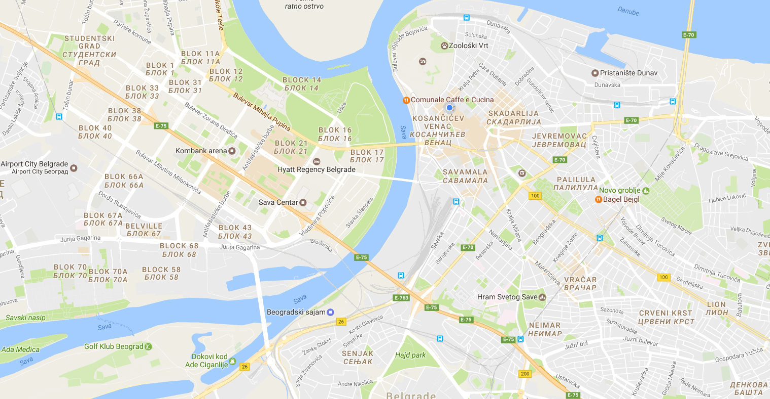
A
A map with most important locations is available at the following link.

