Enclosure 3: Information on hotels

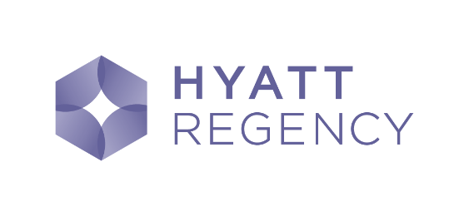(Official Partner) | King/Twin Room – Single Use 65 EUR  King/Twin Room – Double Use 80 EUR  Deluxe Room– Single Use 95 EUR  Deluxe Room– Double Use 110 EUR  Club King/Twin Room– Single Use 145 EUR  Club King/Twin Room– Double Use 160 EUR  (Breakfast & Wifi included) | Milentija Popovica 5  11000 Belgrade  Link
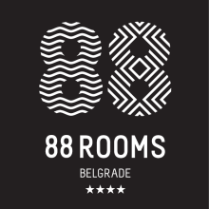 | Single Room: 80 EUR  Double Room: 90 EUR  (Breakfast included) | Takovska 49  11000 Belgrade  Link
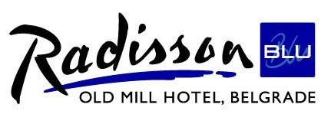 | Single Room: 80 EUR  Double Room: 80 EUR  (Breakfast included) | Bulevar Vojvode Misica 15  11000 Belgrade  Link

The above rates are per night excluding VAT (10%) and tourist tax (1.5 EUR p.p.). All rooms are non-smoking.
Room reservation
In order to book a room, please send an email to Mr. Ognjen Popović, ognjen.popovic@geciclaw.com, with the following information:
- Full name/-s
- Name of hotel (Admiral / Wakeup)
- Room type
- Arrival date
- Departure date
- Nationality
- E-mail address
Questions
If you have any questions regarding the hotel or your reservation, please contact Mr. Ognjen Popović by email ognjen.popovic@geciclaw.com or by phone +381 63 242 048.
Additional Information
We acknowledge that hotels are not everyone’s cup of tea, so we’d like to point out that Airbnb prices in Belgrade are exceptionally affordable, averaging $20-25 for a posh flat for two in the city center.

