Annual Reunion of the Harvard Law School Association of Europe

Thursday, 30 May – Sunday, 2 June 2019

Budapest, Hungary

Thursday, May 30

OPENING RECEPTION AND DINNER AT THE HUNGARIAN ACADEMY OF SCIENCES

Keynote Speaker: Dr. Istvan Stumpf (Member of Hungarian Constitutional Court)
Artistic Performance: Gergo Kovacs Jazz Trio

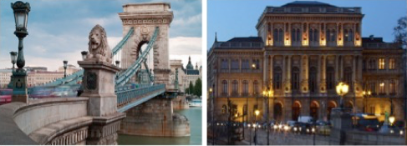

The Hungarian Academy of Sciences is the most important and prestigious learned society of Hungary with its amazing seat at the bank of the Danube offering a breathtaking view to the Chain Bridge and the Buda Castle. We shall kick-start our Annual Reunion in the heart of Budapest surrounded by the atmosphere of this stunning venue evoking the spirit and impression of the Austro-Hungarian Empire.

Friday, May 31

DANUBE CRUISE TO VISEGRÁD, THE ANCIENT CASTLE OF HUNGARIAN KINGS

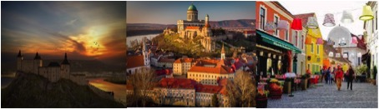

Leave Budapest behind and set off on a half-day trip to the Danube Bend, the River’s most romantic area. Castle ruins, churches, pretty houses perching on the hills and thick forests reflected in the waters of the river make this section of the Danube a global sought after, must-see destination. We shall explore Visegrád to see the ruins of the Early Renaissance summer palace of King Matthias Corvinus of Hungary and the medieval citadel.

LUNCH AT PANORAMA RESTAURANT IN VISEGRAD

Keynote Speaker: Dr. Denes Kemeny (former coach of the Hungarian Waterpolo Team for 15 years, 3 times Olympic Champion, World Champion, World Cup Champion, 2 times World League Champion, 2 times European Champion)

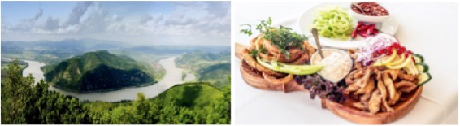

Lunch will be offered at the top of the hill, atmospheric, open-air panorama restaurant in Visegrád overlooking the Danube River’s world-famous bend.

FESTIVE RECEPTION AT THE MUSEUM OF FINE ARTS INCLUDING A PRIVATE GUIDED VISIT OF THE TEMPORARY MICHELANGELO EXHIBITION

Keynote Speaker: Dr. Laszlo Trocsanyi (Minister of Justice)
Artistic Performance: Andrea Rost (Opera Singer) Aleksander Simic (Prodégée cellist, winner of national and international music competitions)

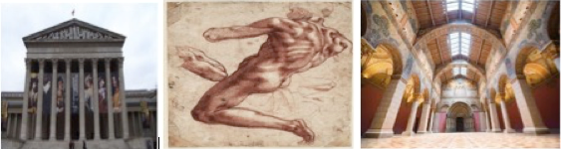

We will be welcomed in marvelous settings at the Museum of Fine Arts, one of Europe’s most prominent museums. During the reception and cocktail dinner, we shall have the opportunity to visit the special Michelangelo Exhibition that Hungary hosts for the first time in history, presenting a stunning range and number of works by the towering genius.

Optional: Night at the world-famous Ruin Pub Szimpla Kert

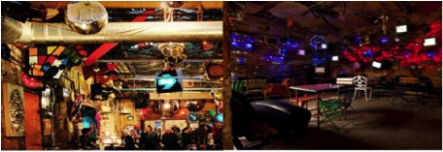

What is unique about contemporary Budapest? The answer, without a doubt, are the ruin bars. Szimpla Kert is an iconic party place, unquestionably the city’s most famous nightspot that has inspired wave after wave of “ruin pubs” that have popped up in the years since it opened.

Saturday, June 1

VISIT AND GUIDED TOUR OF THE BUDA CASTLE

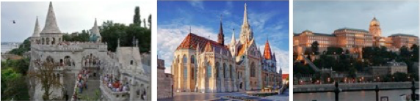

Sprawling over a hill above the city, Buda Castle's Versailles-like appearance suggests its all plush and opulent luxury inside. Destroyed by fire in World War II, this imposing 13th-century palace was rebuilt with modern interiors while incorporating hidden walls and medieval structures that remained unchanged over the centuries. We will visit this UNESCO world heritage site that also hosts two iconic Hungarian landmarks, the Matthias Church and the Fisherman’s Bastion.

PRIVATE VISIT OF THE HUNGARIAN PARLIAMENT

Academic Session at the Hungarian Parliament

Opening Remarks: Dr. Laszlo Palkovics (Minister for Technology and Innovation)
Keynote Speaker: Prof. Chris Bavitz

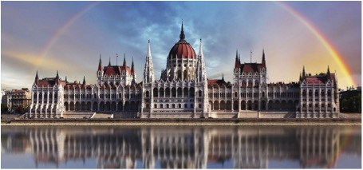

The Hungarian Parliament is a must-see attraction in Budapest. The massive, neo-Gothic building ranks among the top 25 landmarks of the world. The Parliament serves as both a vibrant government center and a proud Hungarian national attraction on the banks of the Danube.

GALA DINNER AND DANCING NIGHT AT „MUSEUM KISCELLI”

Guest of Honor: Andrea Osvart (Actress)
Artistic Performance: Hungarian 100 Members Gipsy Orchestra
Bestow of the HLSA of Europe Award

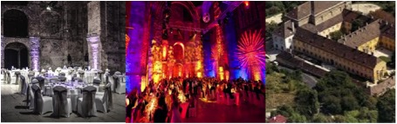

Our traditional Gala Dinner will be held at Museum Kiscelli, one of the hidden treasures of Óbuda located in a former baroque monastery and church on top of the hill. Following the long-standing tradition of our Association, dinner will be followed by dancing.

Sunday, June 2

Optional: Visit of Széchenyi Thermal Bath

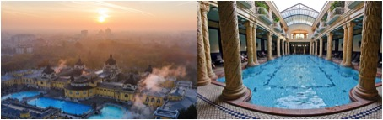

Relaxing in this most visited and much praised attraction in Budapest whisks you back in time among giant pillars and soothing pools and puts you and your aching limbs in the largest medicinal bath in Europe. The palace-like edifice contains a huge thermal pool where people often play chess while immersed in chest-high hot water. A unique experience for all.

FAREWELL BRUNCH AT HOTEL CORINTHIA

Book presentation: Dr. Laszlo Albert Barabasi
“The Formula –The Universal Laws of Success”

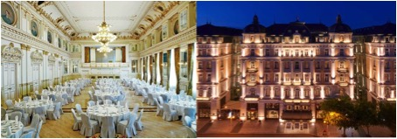

We look forward to seeing you and your guests at our 2019 Reunion!

